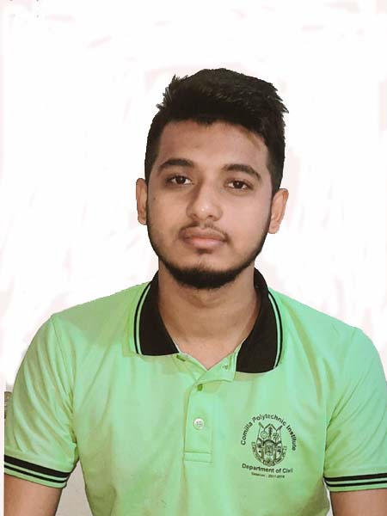Curriculum vitae

**Name**  :Shaiful Islam

**Father’s Name**  :MD. Abdul Jabber

**Mother’s Name**  :Saleha Begum

**Present address**  : Cumilla cantonment , Village-Shaheb Nagar

**Permanent address**  :Cumilla cantonment Shaheb Nagar.

**Post office**  :cumilla cantonment, post code-3501

**Zila**  :cumilla.

**Upozila** :Adarsha Sadar Cumilla

**Date of birth**  :01-02-2002

**Sex**  :Male

**Religion**  :Islam

**Nationality**  :Bangladeshi

**Mobile**  :01885-249492

**Education qualification**  :

|  |  |  |  |  |
| --- | --- | --- | --- | --- |
| degrees | Group | Board | Pass year | Result (GPA) |
| S.S.C | R.A.C | Bd technical education board dhaka | 2017 | 4.75 |
| Diploma in Engineering | Civil Technology | BD technical education baord dhaka | Internship Running |  |

:

**Date** : **signature**

(Shaiful Islam)